Simple Linear Regression to predict closing prices

|  |  |  |
| --- | --- | --- |
| Dependent variable | Independent Variable | Accuracy scores |
| Closing price | Opening price | R2_Score----> 99.98956633448769  MSE is---> 0.29260099042432247  MAE is---> 0.5097455826258013  RMSE is---> 0.5409260489422953 |
| Closing price | High price | R2_Score----> 99.81656752501006  MSE is---> 4.265415741906542  MAE is---> 1.373566184293283  RMSE is---> 2.0652882951071363 |
| Closing price | low | R2_Score----> 99.8046547407898  MSE is---> 4.542427636042642  MAE is---> 1.384939244910529  RMSE is---> 2.131297172156582 |
| Closing price | last | R2_Score----> 99.47769182367398  MSE is---> 12.145404010656975  MAE is---> 0.5474338240783954  RMSE is---> 3.4850256829264508 |
| Closing price | Total traded quantity | R2_Score----> 0.7990974847548848  MSE is---> 2306.751251233312  MAE is---> 34.2427067260846  RMSE is---> 48.02865031659032 |

|  |  |  |
| --- | --- | --- |
| Dependent variable | Independent Variable | Accuracy scores |
| Close | Opening and low | R2_Score----> 99.80164107588364  MSE is---> 4.612505378450527  MAE is---> 1.4016534254608928  RMSE is---> 2.1476744116486857 |
| Close | Opening and last | R2_Score----> 99.55878871182419  MSE is---> 10.259631366775016  MAE is---> 0.599744500180032  RMSE is---> 3.2030659323178186 |
| Close | Opening and high | R2_Score----> 99.62590997086757  MSE is---> 8.698838628434126  MAE is---> 1.6658157749878937  RMSE is---> 2.949379363261723 |
| Close | Opening and Total Trade Quantity | R2_Score----> 98.46231965047583  MSE is---> 35.756187497554585  MAE is---> 2.677530598971021  RMSE is---> 5.979647773703279 |
| Close | |  |  |  | | --- | --- | --- | | Open | High | Low | | R2_Score----> 98.46231965047583  MSE is---> 35.756187497554585  MAE is---> 2.677530598971021  RMSE is---> 5.979647773703279 |
| Close | Open, last, low, and Total Trade Quantity | R2_Score----> 99.83968263720236  MSE is---> 3.7279124267147763  MAE is---> 0.8584448144247486  RMSE is---> 1.930780263705525 |
| Close | Open, high, total traded quantity | R2_Score----> 99.62608277159273  MSE is---> 8.694820436271575  MAE is---> 1.6680169658681903  RMSE is---> 2.94869809174686 |

|  |  |  |
| --- | --- | --- |
| Close | [1,2,3,4,7] | R2_Score----> 99.84420773686121  MSE is---> 3.6226887943149073  MAE is---> 0.8571709480103069  RMSE is---> 1.9033362273426384 |
| Close | [1,2,3,4] | R2_Score----> 99.8322440376059  MSE is---> 3.9008846325257576  MAE is---> 0.8601734133059126  RMSE is---> 1.9750657286596205 |
| Close | [1,2,6,7] | R2_Score----> 99.61551774596478  MSE is---> 8.940492456068768  MAE is---> 1.7821185171076765  RMSE is---> 2.9900656273849187 |
| Close | [3,6,7] | R2_Score----> 99.83871591436096  MSE is---> 3.750391951269729  MAE is---> 1.303007266991847  RMSE is---> 1.9365928718421248 |
| Close | [1,2,6,7] | R2_Score----> 99.61551774596478  MSE is---> 8.940492456068768  MAE is---> 1.7821185171076765  RMSE is---> 2.9900656273849187 |
| Close | [2,4,7] | R2_Score----> 99.55991744241545  MSE is---> 10.233384622665987  MAE is---> 0.5281010035750664  RMSE is---> 3.198966180294188 |
| tottal traded quantity | [1,2,3,4] | R2_Score----> 32.92589856440522  MSE is---> 20797088.947809726  MAE is---> 2239.4836330484845  RMSE is---> 4560.382544020811 |
| Close | [1,2,3] | R2_Score----> 28.87971241009215  MSE is---> 22051655.040378932  MAE is---> 2291.914189633077  RMSE is---> 4695.918977194872 |

|  |  |  |
| --- | --- | --- |
| Total traded quantity | [1,2] | R2_Score----> 26.616488275112914  MSE is---> 22753393.455603004  MAE is---> 2345.009838498867  RMSE is---> 4770.051724625531 |
| Total traded quantity | [2,3] | R2_Score----> 28.93405828070105  MSE is---> 22034804.484340034  MAE is---> 2293.1479643666476  RMSE is---> 4694.124464086996 |
| Total traded quantity | [3,4,2] | R2_Score----> 32.93533518179195  MSE is---> 20794163.017130703  MAE is---> 2242.732098079837  RMSE is---> 4560.061733916626 |
| Total traded quantity | 3:4 | R2_Score----> 24.045372276458632  MSE is---> 23550597.249238525  MAE is---> 2411.3260089408013  RMSE is---> 4852.895759156437 |
| Total traded quantity | 4:5 | R2_Score----> 26.160053916245886  MSE is---> 22894916.12615729  MAE is---> 2361.7212180324564  RMSE is---> 4784.863229618721 |
| Total traded quantity | 5:6 | R2_Score----> 25.811841116544876  MSE is---> 23002883.46993306  MAE is---> 2374.247000304831  RMSE is---> 4796.132136412951 |
| Total traded quantity | 6:7 | R2_Score----> 89.15426517446579  MSE is---> 3362843.5870673163  MAE is---> 1118.8032493132378  RMSE is---> 1833.8057659052433 |
| Total traded quantity | [1,2] | R2_Score----> 26.616488275112914  MSE is---> 22753393.455603004  MAE is---> 2345.009838498867  RMSE is---> 4770.051724625531 |

|  |  |  |
| --- | --- | --- |
| Total traded quantity | [1,3] | R2_Score----> 24.46321018629063  MSE is---> 23421041.847219657  MAE is---> 2392.6804761199246  RMSE is---> 4839.529093539955 |
| Total traded quantity | [1,4] | R2_Score----> 26.208822494942808  MSE is---> 22879794.872986387  MAE is---> 2361.235499852742  RMSE is---> 4783.282855214229 |
| Total traded quantity | [1,5] | R2_Score----> 25.86168908560661  MSE is---> 22987427.539488133  MAE is---> 2374.197244361036  RMSE is---> 4794.5205745192225 |
| Total traded quantity | [1,6] | R2_Score----> 96.34461108441985  MSE is---> 1133394.9585467747  MAE is---> 736.1511957166251  RMSE is---> 1064.6102378555142 |
| Total traded quantity | [2,3] | R2_Score----> 28.93405828070105  MSE is---> 22034804.484340034  MAE is---> 2293.1479643666476  RMSE is---> 4694.124464086996  CodeText |
| Total traded quantity | [2,4] | R2_Score----> 26.312652454566788  MSE is---> 22847601.211654663  MAE is---> 2350.765971562203  RMSE is---> 4779.916444003458 |
| Total traded quantity | [2,5] | R2_Score----> 26.27492852105251  MSE is---> 22859297.946817204  MAE is---> 2351.708249968783  RMSE is---> 4781.139816698232 |
|  | [2,6] | R2_Score----> 96.45163729358097  MSE is---> 1100210.2636491787  MAE is---> 729.6384693837009  RMSE is---> 1048.9090826421414 |
|  | [3,4] | R2_Score----> 30.792687466403823  MSE is---> 21458515.340412077  MAE is---> 2307.6127254276194  RMSE is---> 4632.333681894265 |
|  | [3,5] | R2_Score----> 33.234214475218295  MSE is---> 20701492.08875435  MAE is---> 2259.2456917773306  RMSE is---> 4549.889239174328 |
|  | [3,6] | R2_Score----> 26.059709202079915  MSE is---> 22926029.14744697  MAE is---> 2366.339250836012  RMSE is---> 4788.113318150164 |
|  | [5,6] | R2_Score----> 96.45281378573219  MSE is---> 1099845.4788605403  MAE is---> 725.3022795791051  RMSE is---> 1048.7351805201065 |
|  | [1,2,4] | R2_Score----> 26.695121804867227  MSE is---> 22729012.234273475  MAE is---> 2344.9149232204118  RMSE is---> 4767.495383770547 |
|  | [1,2,5] | R2_Score----> 26.60146387265787  MSE is---> 22758051.942672644  MAE is---> 2347.6513185449953  RMSE is---> 4770.54000535292 |
|  | [1,2,6] | R2_Score----> 96.43834289891915  MSE is---> 1104332.3421022845  MAE is---> 730.3604622734096  RMSE is---> 1050.8721816197651 |

LOGISTIC REGRESSION PREDICTION

|  |  |  |
| --- | --- | --- |
| TREND | 2:4 | [[ 0 1 0]  [ 0 134 0]  [ 0 112 0]]  54.25101214574899  precision recall f1-score support  0 0.00 0.00 0.00 1  1 0.54 1.00 0.70 134  2 0.00 0.00 0.00 112  accuracy 0.54 247  macro avg 0.18 0.33 0.23 247  weighted avg 0.29 0.54 0.38 247 |
| TREND | 1:2 | [[ 0 1 0]  [ 0 134 0]  [ 0 112 0]]  54.25101214574899  precision recall f1-score support  0 0.00 0.00 0.00 1  1 0.54 1.00 0.70 134  2 0.00 0.00 0.00 112  accuracy 0.54 247  macro avg 0.18 0.33 0.23 247  weighted avg 0.29 0.54 0.38 247 |
| TREND | 2:3 | [[ 0 1 0]  [ 0 134 0]  [ 0 112 0]]  54.25101214574899  precision recall f1-score support  0 0.00 0.00 0.00 1  1 0.54 1.00 0.70 134  2 0.00 0.00 0.00 112  accuracy 0.54 247  macro avg 0.18 0.33 0.23 247  weighted avg 0.29 0.54 0.38 247 |
| TREND | 3:4 | [[ 0 1 0]  [ 0 134 0]  [ 0 112 0]]  54.25101214574899  precision recall f1-score support  0 0.00 0.00 0.00 1  1 0.54 1.00 0.70 134  2 0.00 0.00 0.00 112  accuracy 0.54 247  macro avg 0.18 0.33 0.23 247  weighted avg 0.29 0.54 0.38 247 |
| TREND | 4:5 | [[ 0 1 0]  [ 0 134 0]  [ 0 112 0]]  54.25101214574899  precision recall f1-score support  0 0.00 0.00 0.00 1  1 0.54 1.00 0.70 134  2 0.00 0.00 0.00 112  accuracy 0.54 247  macro avg 0.18 0.33 0.23 247  weighted avg 0.29 0.54 0.38 247 |
| TREND | 5:6 | [[ 0 1 0]  [ 0 134 0]  [ 0 112 0]]  54.25101214574899  precision recall f1-score support  0 0.00 0.00 0.00 1  1 0.54 1.00 0.70 134  2 0.00 0.00 0.00 112  accuracy 0.54 247  macro avg 0.18 0.33 0.23 247  weighted avg 0.29 0.54 0.38 247 |
| TREND | 6:7 | [[ 0 1 0]  [ 0 123 11]  [ 0 100 12]]  54.655870445344135  precision recall f1-score support  0 0.00 0.00 0.00 1  1 0.55 0.92 0.69 134  2 0.52 0.11 0.18 112  accuracy 0.55 247  macro avg 0.36 0.34 0.29 247  weighted avg 0.53 0.55 0.45 247 |
| TREND | [1,2] | [[ 0 0 1]  [ 0 134 0]  [ 0 106 6]]  56.68016194331984  precision recall f1-score support  0 0.00 0.00 0.00 1  1 0.56 1.00 0.72 134  2 0.86 0.05 0.10 112  accuracy 0.57 247  macro avg 0.47 0.35 0.27 247  weighted avg 0.69 0.57 0.43 247 |
|  |  |  |
| TREND | [1,3] | [[ 0 0 1]  [ 0 134 0]  [ 0 101 11]]  58.70445344129555  precision recall f1-score support  0 0.00 0.00 0.00 1  1 0.57 1.00 0.73 134  2 0.92 0.10 0.18 112  accuracy 0.59 247  macro avg 0.50 0.37 0.30 247  weighted avg 0.73 0.59 0.47 247 |
| TREND | [1,4] | [[ 0 0 1]  [ 0 134 0]  [ 0 54 58]]  77.7327935222672  precision recall f1-score support  0 0.00 0.00 0.00 1  1 0.71 1.00 0.83 134  2 0.98 0.52 0.68 112  accuracy 0.78 247  macro avg 0.57 0.51 0.50 247  weighted avg 0.83 0.78 0.76 247 |
|  | [1,6] | [[ 0 1 0]  [ 0 123 11]  [ 0 98 14]]  55.465587044534416  precision recall f1-score support  0 0.00 0.00 0.00 1  1 0.55 0.92 0.69 134  2 0.56 0.12 0.20 112  accuracy 0.55 247  macro avg 0.37 0.35 0.30 247  weighted avg 0.55 0.55 0.47 247 |
| TREND | [1,7] | [[ 0 1 0]  [ 0 125 9]  [ 0 100 12]]  55.465587044534416  precision recall f1-score support  0 0.00 0.00 0.00 1  1 0.55 0.93 0.69 134  2 0.57 0.11 0.18 112  accuracy 0.55 247  macro avg 0.37 0.35 0.29 247  weighted avg 0.56 0.55 0.46 247 |
| TREND | [1,2,3] | [[ 1 0 0]  [ 0 134 0]  [ 0 94 18]]  61.943319838056674  precision recall f1-score support  0 1.00 1.00 1.00 1  1 0.59 1.00 0.74 134  2 1.00 0.16 0.28 112  accuracy 0.62 247  macro avg 0.86 0.72 0.67 247  weighted avg 0.78 0.62 0.53 247 |
| TREND | [1,2,4] | [[ 0 0 1]  [ 0 134 0]  [ 0 106 6]]  56.68016194331984  precision recall f1-score support  0 0.00 0.00 0.00 1  1 0.56 1.00 0.72 134  2 0.86 0.05 0.10 112  accuracy 0.57 247  macro avg 0.47 0.35 0.27 247  weighted avg 0.69 0.57 0.43 247 |
| TREND | [1,2,5] | [[ 0 0 1]  [ 0 134 0]  [ 0 46 66]]  80.97165991902834  precision recall f1-score support  0 0.00 0.00 0.00 1  1 0.74 1.00 0.85 134  2 0.99 0.59 0.74 112  accuracy 0.81 247  macro avg 0.58 0.53 0.53 247  weighted avg 0.85 0.81 0.80 247 |
| TREND | [1,2,3,4,5,6] | [[ 1 0 0]  [ 0 132 2]  [ 0 41 71]]  82.5910931174089  precision recall f1-score support  0 1.00 1.00 1.00 1  1 0.76 0.99 0.86 134  2 0.97 0.63 0.77 112  accuracy 0.83 247  macro avg 0.91 0.87 0.88 247  weighted avg 0.86 0.83 0.82 247 |
| TREND | [1,2] | [[ 0 0 1]  [ 0 134 0]  [ 0 106 6]]  56.68016194331984  precision recall f1-score support  0 0.00 0.00 0.00 1  1 0.56 1.00 0.72 134  2 0.86 0.05 0.10 112  accuracy 0.57 247  macro avg 0.47 0.35 0.27 247  weighted avg 0.69 0.57 0.43 247 |
| TREND | [1,2,3,4] | [[ 1 0 0]  [ 0 134 0]  [ 0 52 60]]  78.94736842105263  precision recall f1-score support  0 1.00 1.00 1.00 1  1 0.72 1.00 0.84 134  2 1.00 0.54 0.70 112  accuracy 0.79 247  macro avg 0.91 0.85 0.85 247  weighted avg 0.85 0.79 0.77 247 |
| TREND | [1,2,5] | [[ 0 0 1]  [ 0 134 0]  [ 0 46 66]]  80.97165991902834  precision recall f1-score support  0 0.00 0.00 0.00 1  1 0.74 1.00 0.85 134  2 0.99 0.59 0.74 112  accuracy 0.81 247  macro avg 0.58 0.53 0.53 247  weighted avg 0.85 0.81 0.80 247 |
| TREND | [4,5,6] | [[ 0 1 0]  [ 0 121 13]  [ 0 100 12]]  53.84615384615385  precision recall f1-score support  0 0.00 0.00 0.00 1  1 0.55 0.90 0.68 134  2 0.48 0.11 0.18 112  accuracy 0.54 247  macro avg 0.34 0.34 0.28 247  weighted avg 0.51 0.54 0.45 247 |
| TREND | [6,7] | [[ 0 1 0]  [ 0 121 13]  [ 0 98 14]]  54.655870445344135  precision recall f1-score support  0 0.00 0.00 0.00 1  1 0.55 0.90 0.68 134  2 0.52 0.12 0.20 112  accuracy 0.55 247  macro avg 0.36 0.34 0.30 247  weighted avg 0.53 0.55 0.46 247 |

##stock price prediction using KNN

Train_data Accuracy: 0.62

Test_data Accuracy: 0.51

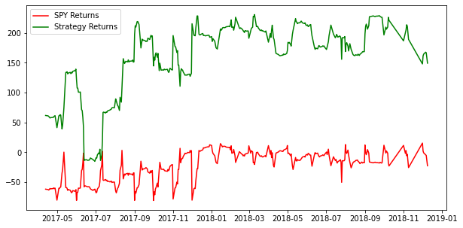

#Stock Market Prediction with Decision Tree

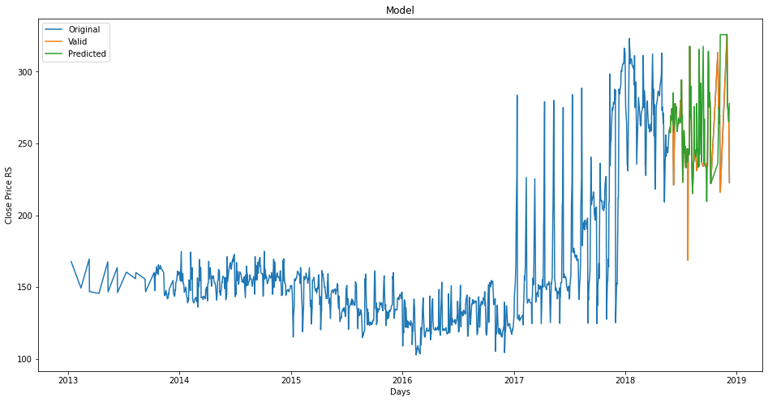

#stock price prediction using LMSM Model

